# SQL Database - Creating a new Azure SQL Database on Azure

**Prerequisites**

* Azure account.

Now let's get started with the following steps,  
  
**Create a new Azure SQL database  
  
Step 1-** Sign in to the online [Microsoft Azure Portal](https://portal.azure.com/).  
  
**Step 2-** Click New, type SQL Database, and then click SQL Database.  
  
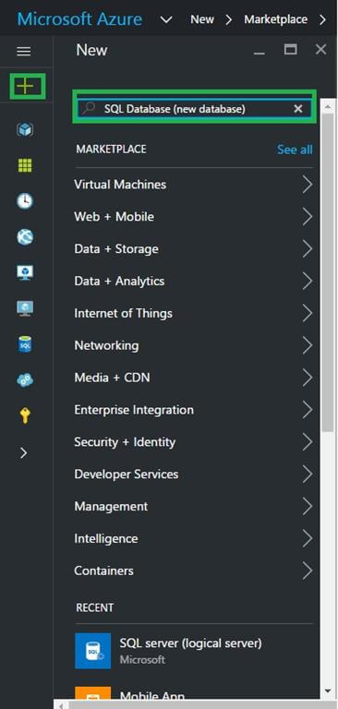  
  
**Step 3-** Click SQL Database (new database).  
  
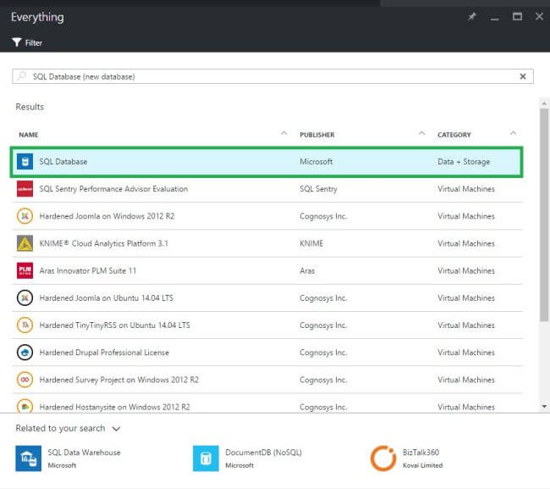  
  
**Step 4-** Click Create to create a new database in the SQL Database service.  
  
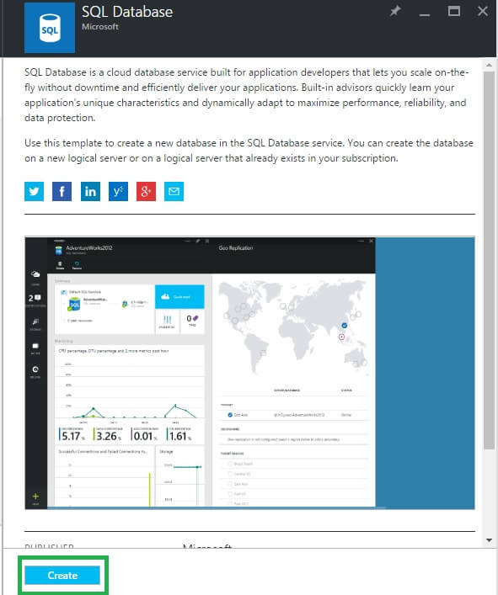  
  
**Step 5-** Provide the values for the following server properties, **Subscription** - This applies only if you have multiple subscriptions.  
  
**Resource group** - If you're just getting started, use the resource group of the logical server.  
  
**Select source** - You can choose a blank database, sample data, or an Azure database backup. To migrate an on-premises SQL Server database or load data by using the BCP command-line tool, see the links at the end of this article.  
  
**Server** - A new or existing logical server.  
  
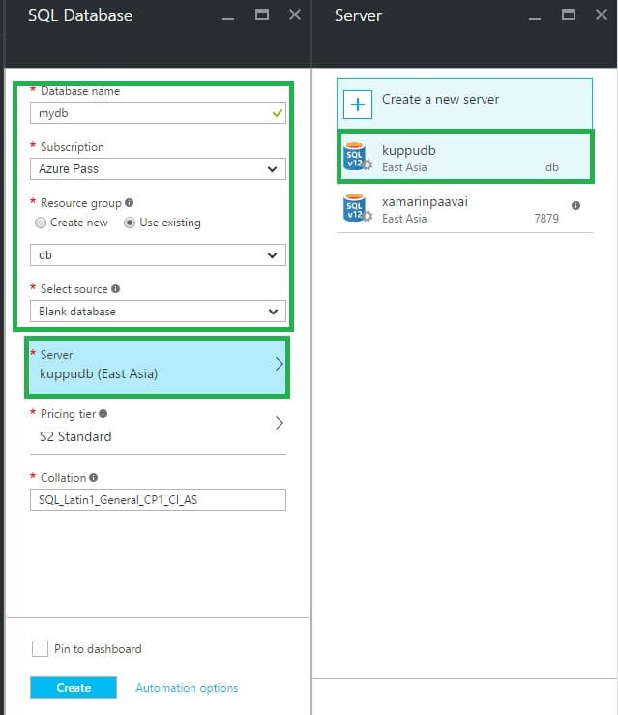  
  
**Pricing tier** - If you're just getting started, use the default value S0.  
  
**Collation** - This applies only if a blank database was chosen.  
  
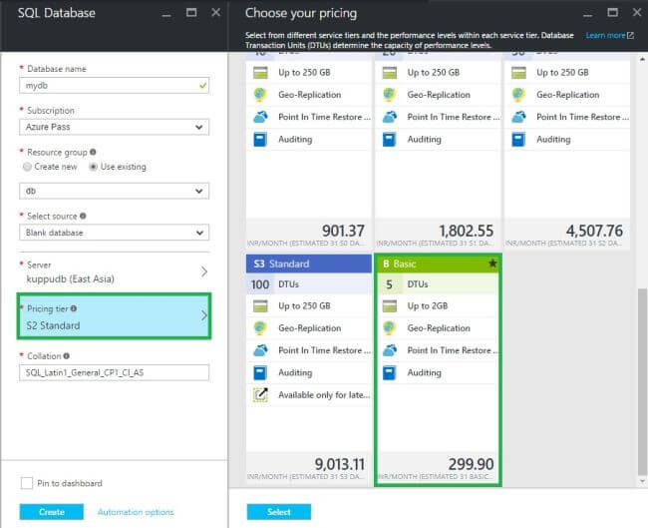  
  
Click Create. In the notification area, you can see that deployment has started.  
  
Create  
  
Then few minutes later we will get New Azure SQL Database.  
  
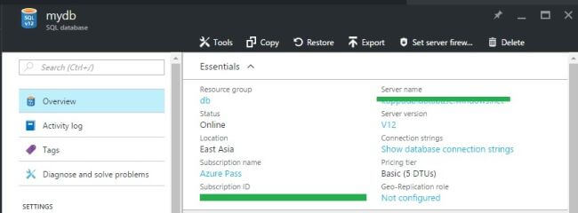  
  
**Summary**In this article we discussed about how to create a New Azure SQL Database by using Azure Portal.